Burrana Inc. Quality Systems Manual

Quality Manual / Documented Information
Document No. QSM-441-1

Locations and Scope
El Porvenir, Progreso,
21188 Mexicali, Baja California
AS9100 Scope:
Sales, Customer Support, Purchasing, Assembly, Inspection, Testing, Final Inspection, Warehousing, and Shipping/Receiving of In-Seat Power Systems and other Electrical/Electronic Cabin Systems
AS9110 Scope:
Maintenance, Fabrication, and Support of In-Seat Power Systems, In-Flight Entertainment Systems, and Other Electrical / Electronic Cabin Systems.
743 West 1200 North, Suite 100
Springville, Utah 84003
AS9100 Scope:  Customer Support, Operations (Production and Repair), Stores Management, and Quality Control of In-Seat Power Systems and Other Electrical/Electronic Cabin Systems.  Satellite site for Part 21  1757 Carr Road, Suite 100 E  Calexico, CA 92231 |  | AS9110 Scope:  Production Planning, Quality Control, Logistics, and Maintenance of In-Seat Power Systems and other Electrical/Electronic Cabin Systems.
Engineering
Unit 5/53 Southgate Ave,  Cannon Hill QLD 4170, Australia |  | 1733 Alton Pkwy,  Irvine, CA 92606, United States
AS9100 Scope:
Engineering and Design Validation of In-Seat Power Systems, In-Flight Entertainment Systems, and other Electrical/Electronic Cabin Systems.

Tel:
+1 (385) 500-3026
Email: support@burrana.aero
Web Site: www.burrana.aero

Table of Contents
1 Introduction 3
Company Overview — Products, Services, and Market Position 3
Vision 3
Mission 3
2 Scope of the Quality Management System by Manual 4
PQM-422-1 Scope 4
SPR-RSM-841-01 Scope 4
QA-RSM-440-01 Scope 4
Exclusions 4
3 Document Information 5
Approval, Responsibility, Control, and Distribution 5
Terms and Definitions 5
References 5
4 Context of the Organization 6
Applicable Standards and Regulations 6
Quality Policy 6
Safety Policy 6
Quality Objectives 6
Work Health and Safety 6
Organization chart 7
5 Tables and Diagrams 7
Table 1: QMS System Diagram AS9100/AS9110 7
Table 2: Burrana Locations / Functions Matrix 7
Table 3 - Burrana Interested Parties 8
6 Reference Documents, Standards, and Regulations 8

Introduction
The Top Management of Burrana has established a Quality Management System (QMS) to document best practices, meet customer requirements, and enhance overall management. The QMS aligns with regulations addressing the design, development, assembly, installation, and servicing of our products, while applying a Risk Based Approach ensuring that processes are managed effectively and prevents undesirable outcomes while enhancing performance. The Key Processes of the QMS are captured in this manual. The Outline, structure, responsibilities, and other information necessary to maintain compliance are contained in this manual.
Burrana Inc. integrates environmental sustainability into its QMS in compliance with AS9100 and AS9110 standards when required by interested parties, ensuring adherence to relevant environmental regulations and continual improvement practices.

Company Overview — Products, Services, and Market Position
Burrana provides innovative solutions for airlines, enhancing the inflight experience through trusted, reliable, and high-performance products. Our offerings improve operational and cost efficiencies while enabling ancillary revenue opportunities, offering passengers comfort and control, and supporting airline staff in delivering exceptional service.
To become the leader in our industry, Burrana has identified that In-flight amenities like In Seat Power Solutions, cabin lighting, entertainment systems, and connectivity, are vital to enhancing passenger experiences, with in-seat power rated as the most influential.

Vision
To be the leading global supplier of innovative power solutions for aircraft by 2029.

Mission
To design and manufacture power systems that provide our airline customers with the highest value proposition.

Scope of the Quality Management System by Manual
PQM-422-1 Scope: This FAA PMA/STC Quality Manual is an introduction and guide through the Quality System requirements for Burrana for the manufacturing of articles as a Production Approval Holder (PAH).
As a result of Burrana’s need to hold Parts Manufacturing Approvals (PMAs) and to be granted production approval holder status from the Federal Aviation Administration (FAA), this document was written to fulfill the requirements for a Quality Manual.

SPR-RSM-841-01 Scope: This Repair Station Manual (RSM) is a statement of how Burrana, Inc. (Burrana) Repair Station will control maintenance, quality, and administrative processes to ensure product conformance to customer requirements. Burrana will perform or have performed the inspections and tests required to substantiate product conformance to drawing, specifications, and customer contract requirements and perform all inspections and tests otherwise required by customer contract. The system outlined in the RSM and the documents in §1.8 meet the requirements outlined in 14 CFR 145. These documents will hereafter collectively be referred to as this Manual.

QA-RSM-440-01 Scope: This Repair Station Manual (RSM) is a statement of the means by which Co-Production de Tijuana SA de CV. (Burrana Inc.) Mexicali Repair Station will control maintenance, quality, and administrative processes in order to assure product conformance to customer requirements. Burrana will perform or have performed the inspections and tests required to substantiate product conformance to component maintenance manuals, specifications and customer contract requirements and will also perform or have performed all inspections and tests otherwise required by customer contract. Conformity to AS9100 and AS9110 is claimed only if applicable requirements are met. If any requirements are deemed not relevant, justification is documented.
Exclusions:
Engineering activities, including design and development, are excluded from the Repair Station scope, as Repairs are made per approved CMMs and regulatory approvals.

Document Information

Approval, Responsibility, Control, and Distribution
The VP Quality has the final authority to approve and distribute this Quality Manual. Process owners may revise and approve the sections that are relevant to their expertise with support from the VP Quality.
Burrana maintains the latest approved revision of the Quality Manual in the QMS software which contains the status, a description of changes, revision history, and comments. The Current Approved Revision is accessible to all employees. Any printed copies clearly state “Printed Copies are Uncontrolled” in the footer of each page.
Burrana reserves the right to update this Quality System Manual, and its supporting documents as needed to align with standards and improve processes, provided changes do not compromise product conformity or regulatory compliance and do not require external approval.

Terms and Definitions
Applicable definitions are included in documented procedures and instructions to enhance the understanding of the process. In addition to the terms and definitions listed in ISO 9000, the following are specific to Aviation, Space, and Defense (ASD) quality management system:
TERM | MEANING
Counterfeit Part | An unauthorized copy, imitation, substitute, or modified part such as material, part, component, which is knowingly misrepresented as a specified genuine part of an original or authorized manufacturer.
Critical Items | Those items such as functions, parts, software, characteristics, processes having significant effect on the provision and use of the products and services; including safety, performance, form, fit, function, producibility, service life, etc.; that require specific actions to ensure they are adequately managed.
Key Characteristic | An attribute or feature whose variation has a significant effect on product fit, form, function, performance, service life, or producibility, that requires specific actions for controlling variation.
Product Safety | The state in which a product can perform to its designed or intended purpose without causing unacceptable risk of harm to persons or damage to property.
Special Requirements | Those requirements identified by the customer, or determined by the organization, which have high risks of not being met, thus requiring their inclusion in the operational risk management process.
QwizPro | Burrana QMS Software used for Configuration Management, Storage, Control, and Distribution of the QMS.

References
The Burrana QMS Process Flow Diagram (Table 1), Locations/Functions Matrix (Table 2), and Relevant Interested Parties (Table 3) have been captured within this Quality Manual.

Context of the Organization

Applicable Standards and Regulations
Burrana has identified the specific standards and regulatory requirements (AS9100, AS9110, AS9115, AS9145, ISO 9000, ISO 9001, FAA, EASA, CAA, CAAC, AFAC, and Customer requirements as applicable) and includes them in the internal audit process. Other standards and regulations may also be recognized based on customer requirements that are necessary to enhance customer satisfaction and safety.

Quality Policy
Burrana is committed to providing safe, effective products and services that meet or exceed our aviation customers’ design, performance, safety, and reliability requirements, delivered on time and at the greatest value.
Burrana continuously strives to improve its products, processes, and the effectiveness of its Quality Management System by complying with Customer, Regulatory, and AS series standards.

Safety Policy
Burrana is committed to meeting our health and safety objectives to ensure our employees a safe and productive working environment. Burrana encourages employees to report potential safety violations without fear of retribution to implement corrective action immediately.
We strive to comply with the safety regulations, codes of practice, and safety guidance materials applicable to our sites of operation as a minimum commitment to safety.
At Burrana, we will provide a safe and healthy work environment free from workplace injury and illness. We will achieve this through the participation, cooperation, and commitment of everyone at Burrana.
Burrana is equally committed to product safety, ensuring that all products we design, manufacture, and repair meet the highest standards of safety and reliability. We incorporate product safety into all phases of the product lifecycle and encourage all employees to report any product safety concerns without fear of retribution so that corrective actions can be taken promptly.

Quality Objectives
Burrana has established Quality Objectives that align with the Quality Policy and Safety Policy, supporting the company’s strategic direction using KPIs (Key Performance Indicators) that are aligned with our strategic direction and interested parties. These objectives are communicated to relevant functions at each site, promoting continuous improvement. Objectives are reviewed at least annually for effectiveness and adjusted as necessary.

Work Health and Safety
Burrana promotes a safe work environment, allowing employees to engage in safe work practices, identify hazards, manage Risks, and has the authority and responsibility to report unsafe conditions. Burrana Management Teams promote safety as a core value and take into consideration employees concerns to improve the overall health and safety within Burrana.

Organization chart
Burrana uses the A-530-01 ORG Chart maintained in QwizPro to share the current Organizational Chart with all employees. This chart is updated periodically to align with the current structure.

Tables and Diagrams

Table 1: QMS System Diagram AS9100/AS9110
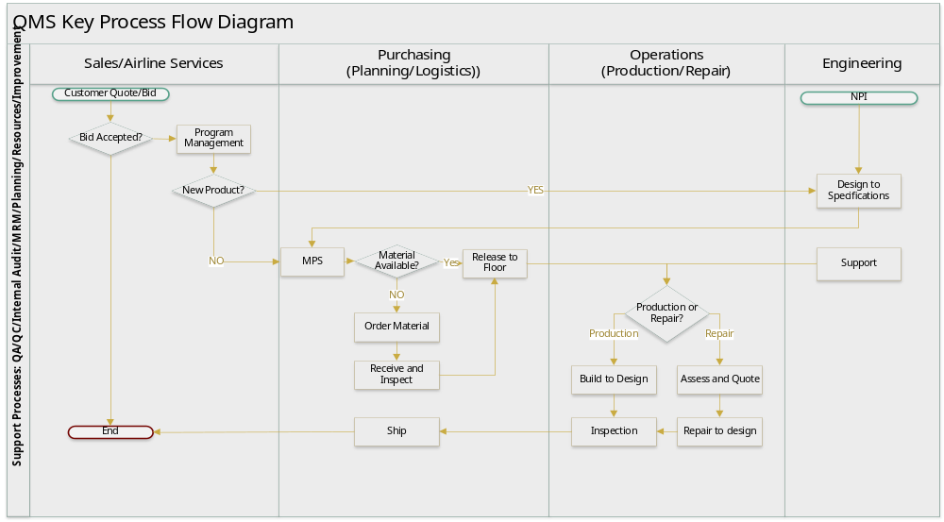

Table 2: Burrana Locations / Functions Matrix
Location | Production | Repair | Sales/Programs | Purchasing | Engineering | Quality
Springville, UT, USA | X | X |  |  |  | X
Calexico, CA, USA |  |  |  |  |  | X
Irvine, CA, USA |  |  |  |  | X | X
Brisbane, QLD, AUS |  |  |  |  | X | X
Mexicali, MX | X | X | X | X |  | X
Subcontractors Using the Burrana System
Toulouse, France |  | X |  |  |  | X
Shanghai, China |  | X |  |  |  | X

Table 3 - Burrana Interested Parties
Who | Need | Expectation | Monitoring Process
Customers | Predictable On-Time Delivery  Product Quality meets expectations  Continuous Innovation | Competitive Pricing, Conforming Product On-Time  Investment in R&D | Delivery Metrics  CARs  Engineering performance metrics
Management | Sales Growth  Profitable Programs  Predictable Delivery | Performance to Meet or Exceed Goals | Profit and Loss Statement  Engineering and Operations on Time Metrics
Employees | Safe Work Environment  Challenge work with growth opportunities | Competitive Conditions | Employee Satisfaction  Employee Retention
Shareholders and Debt Providers | Sales target achievement  Stable financial performance  Strong Cash Flows | Performance to Meet or Exceed Goals | Profit and Loss Statement  Balance Sheet  Cash Flow Statement
Materiel Suppliers | Forward visibility of Demand  Timely Purchase Orders  Timely Payment | On-Time Payment | Supplier Scorecards
Aviation Regulators | Compliance | Continuous Monitoring  Internal Audit  QMS Review and Improvement | CARs
Other Statutory and Regulatory Bodies | Variable Compliance | Compliance to Requirements | Nonconformance Reports
Landlords/ Landowners | Stable financial performance | On-Time Payment | On-Time Payment
Utilities and other non-materiel suppliers | Stable financial performance | On-Time Payment | On-Time Payment

Reference Documents, Standards, and Regulations
Standard | Regulatory Body | Internal Document
AS9100D Quality Management Systems – Requirements for Aviation, Space, and Defense Organizations. | FAA 14 CFR Part 21 | PQM-422-1 Production Quality Manual
AS9110C - Quality Management Systems – Requirements for Aviation Maintenance Organizations | FAA 14 CFR Part 145 | SPR-RSM-841-01 SPR Repair Station Manual
AS9115A - Quality Management Systems – Requirements for Aviation, Space and Defense Organizations – Deliverable Software | EASA Part 145 | QA-RSM-440-01 MXL Repair Station Manual
AS9145 - Aerospace Series – Requirements for Advanced Product Quality Planning and Production Part Approval Process | AFAC Part 145 | A-530-01 Burrana Org Charts
ISO 9000:2015 Quality Management Systems – Fundamentals and Vocabulary. | CAAC Part 145
ISO 9001:2015 Quality Management Systems – Requirements | CAA Part 145

